**GRADUATE DIRECTED PROJECT**

**DEVELOPERS’ MANUAL**

**Project Name: Codeword**

**Team Name: Codeword Vue.js**

**Team Members:**

  Naveen Kumar Chandaluri

  Shivani Reddy Dodla

                  Sravya Kancharla

                                    Sreelekha Vijaya

                        Srimai Reddy Yanala

                            Vyshnavi Yalamareddy

**Table of Contents**

**1.**   **Developers Manual**

**1.1 Instructions to execute the project**

**1.2 Known Errors**

**2.**   **Maintenance Instructions**

**2.1 MongoDB Database**

**2.2 Student and Codeword Sets**

**2.3 Steps that can be followed**

**1.** **Developers’ Manual:**

* 1. **Instructions to execute the project:**

To run this application on local host, below software’s should be installed on the system:

1. Visual Studio Code
2. Tortoise Git
3. Postman
4. Google Chrome Browser
5. MongoDB Compass

These are the technologies:

1. Vue.js
2. Node.js
3. Heroku

1. Clone the project onto your machine from the GitHub Repository using the following link:

<https://github.com/chvnaveenkumar/Codeword-GDPII.git>

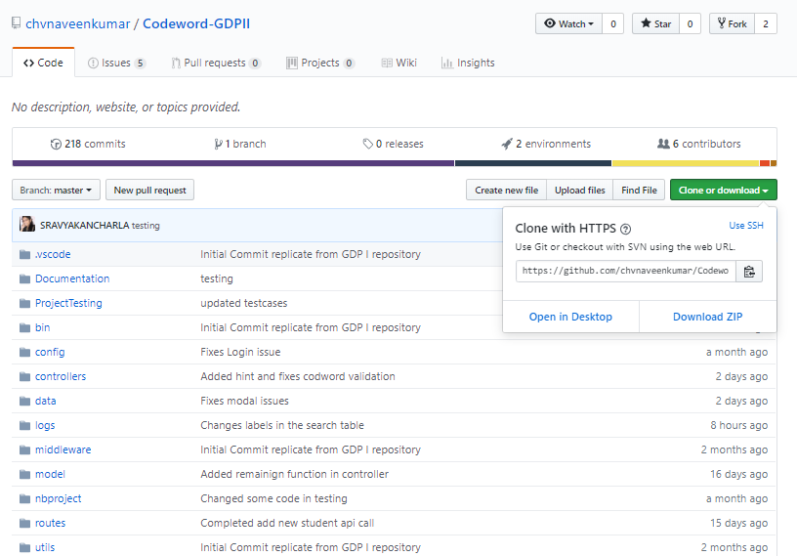

Figure 1

Codeword Git Repository

2. After cloning the project on your machine, you will notice the project folder as follows:

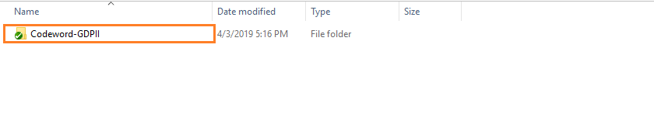

Figure 2

Codeword File after cloning

3. In the “Codeword-GDPII” folder open the folder contents with Visual Studio code as follows:

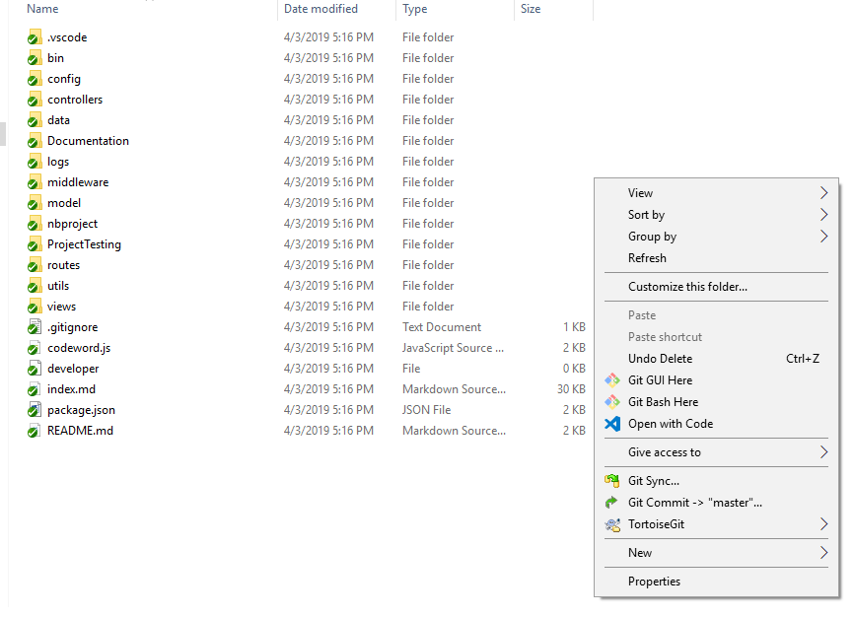

Figure 3

Opening in Visual Studio Code

4. The Visual Studio Code opens the “Codeword-GDPII” as follows:

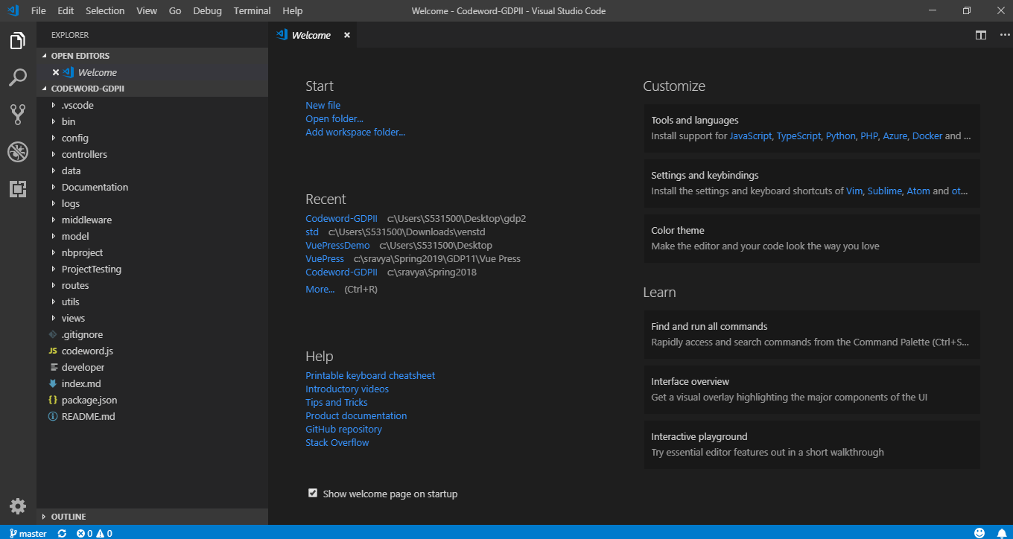

Figure 4

Code in Visual Studio Code

5. To run the project in the Visual Studio Code, click on the “View” option in the navigation bar and click on “Terminal”.

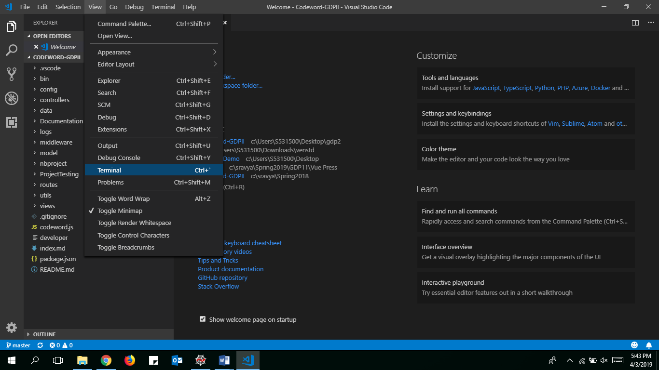

Figure 5

Opening Terminal

6. After clicking on the “Terminal” you will notice a terminal screen at the bottom of the screen in the Visual Studio Code.

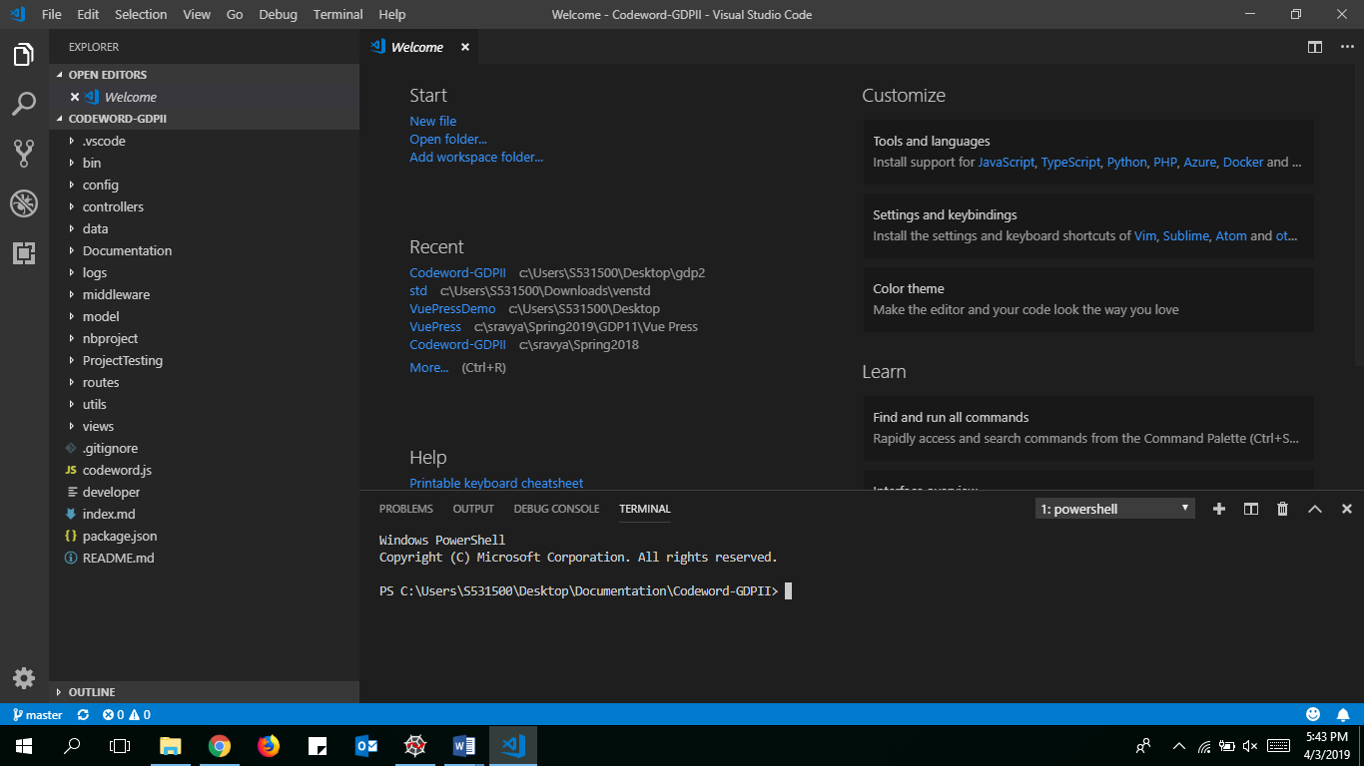

Figure 6

7. In the Terminal window type in **npm install** to install all the necessary dependencies to run the project as follows:

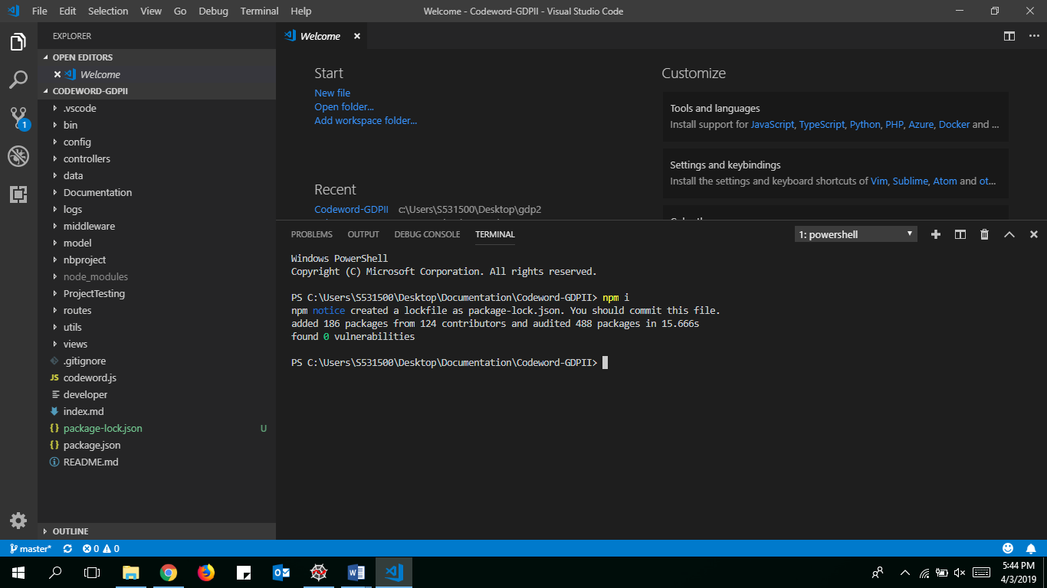

Figure 7

Installing Dependencies

8. In terminal window, type **cd views** to direct path to views folder. Now type **npm install** to install the dependencies to run the project.

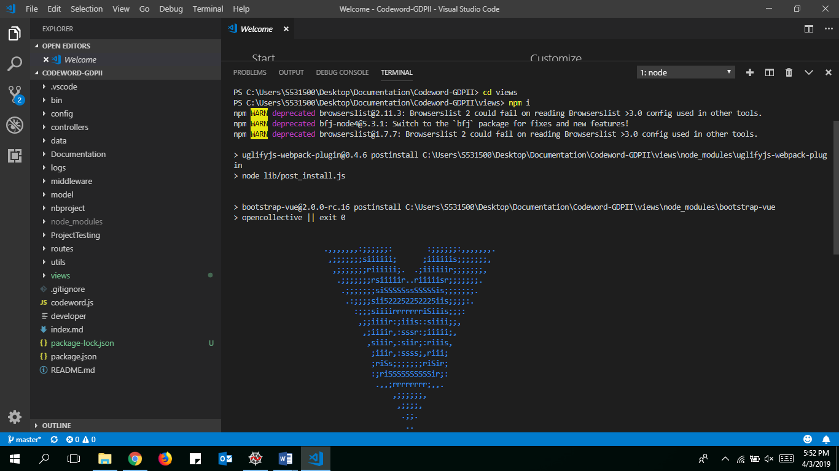

Figure 8

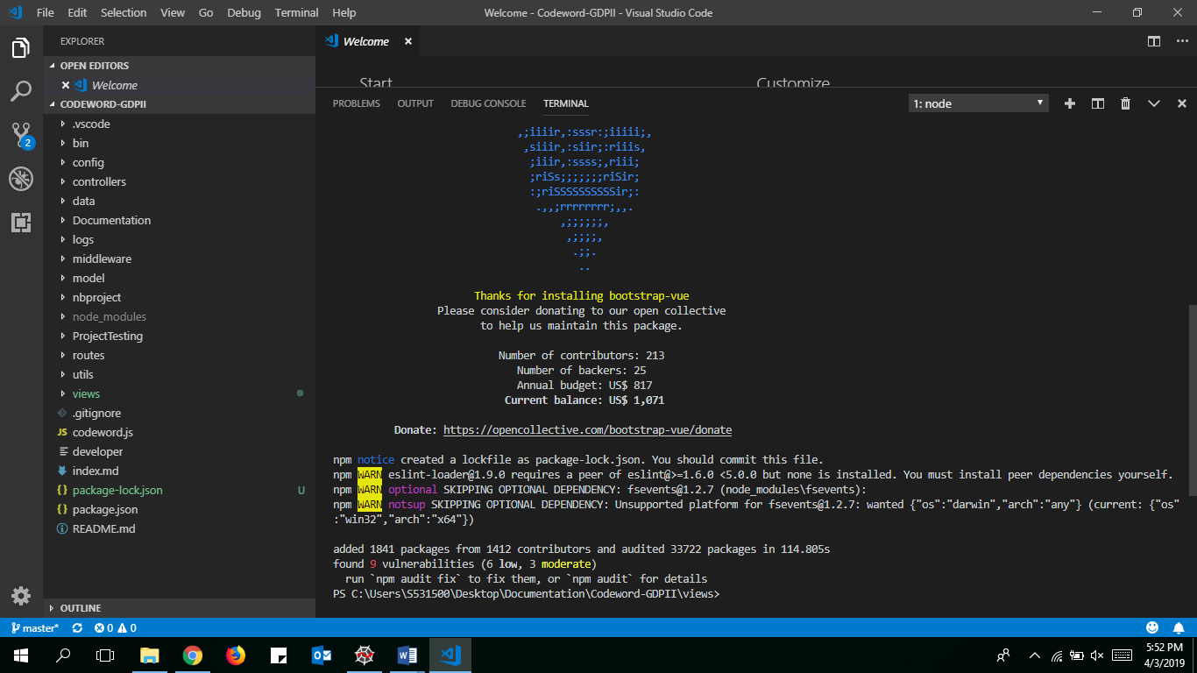

Figure 9

Running Code

9. After installing all the necessary dependencies for the project, type in **npm run dev,**  to connect the project to the backend click f5, as follows:

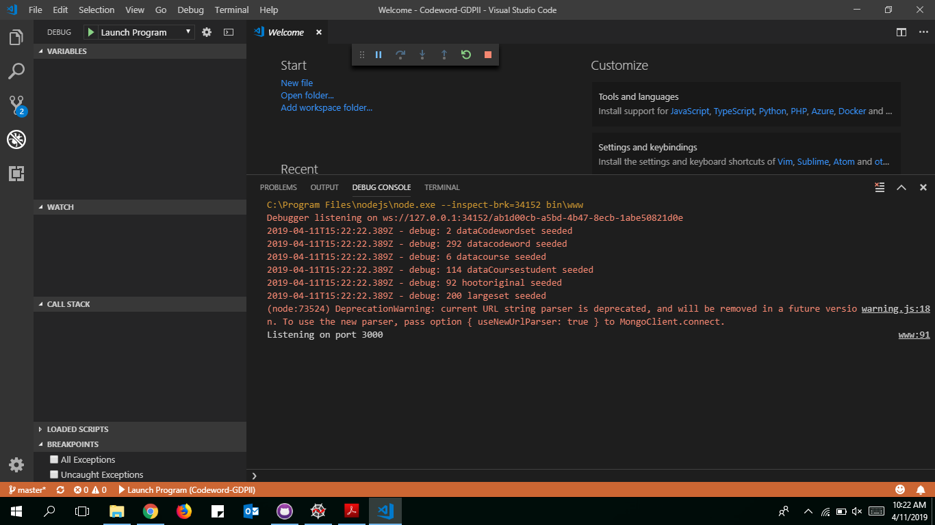

Figure 10

Connecting to Database

10. Now it will redirect to a link in chrome page.

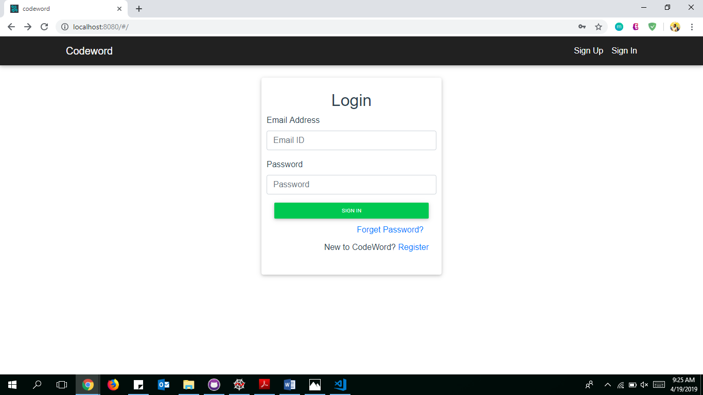

Figure 11

After running code

**1.2 Known Errors:**

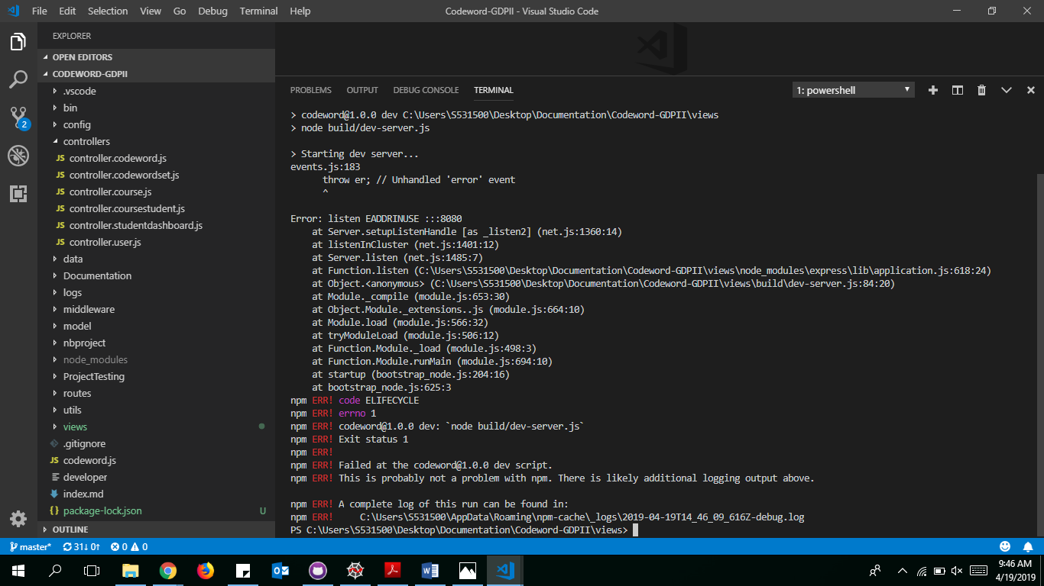

Figure 12

Error while running code

If Sometimes you get an error, to stop that error 2 steps need to be followed:

a) netstat -ano | findstr :8080

b) taskkill /PID typeyourPIDhere /F

PID: Process Identification, It will be shown after running the step (a).

Here is the link to refer : <https://stackoverflow.com/questions/39632667/how-to-kill-the-process-currently-using-a-port-on-localhost-in-windows>

**2. Maintenance Instructions:**

**2.1 MongoDB Database:**

We have used our database as mongodb:

You can see the database by logging in here:

<https://cloud.mongodb.com/user?_ga=2.129681035.688782268.1556715422-874384433.1556715422#/atlas/login>

**Username:** [**naveenkumarchandaluri@gmail.com**](mailto:naveenkumarchandaluri@gmail.com)

**Password:** codeword2$

Here are screenshots for each module in the database:

1. This is collections view in database showing the CodewordSets data.

A screenshot of a computer

Description generated with very high confidence

Figure 13

CodewordSets Data

1. Collections view in database showing the Coure Models data.

A screenshot of a computer

Description generated with very high confidence

Figure 14

Course Models Data

1. Collections view in database showing the Coure Student Models data.

A screenshot of a computer

Description generated with very high confidence

Figure 15

Course Student Models Data

1. Collections view in database showing the User Models data.

A screenshot of a computer screen

Description generated with very high confidence

Figure 16

Users Data

**Heroku deployed Link:** <https://gdpcodeword.herokuapp.com/#/>

* Here you will be able to see the collections view. There you will be able to see the different sets like codewordsets, coursemodels, coursestudentmodels, usermodels.
* You can be able to see the data when we click on each of them.

**2.2 Student and Codeword Sets:**

User can find sample codeword sets and student details as excel files in this link: <https://github.com/chvnaveenkumar/Codeword-GDPII/tree/master/Documentation/Sample%20Data>

**2.3 Steps that can be followed:**

1. After logging into the codeword set, you have to register by clicking on R**egister** button.
2. User can enter .edu mails or emails.
3. User should enter an email, if user is an instructor then check the instructor check box.
4. User should click on **send temporary password,** so that he will get a temporary password to the email.
5. It will redirect to the login page, where we will get a chance to enter email and temporary password.
6. If user forgets password, he/she can click on **Forget Password** and next page will be entering email and send temporary password button.
7. User should click on **login** button where you will redirect to change password page and will get a chance to change the temporary password.

**Student View:**

1. If user is a student, he/she will find their courses if instructor has already invited them.
2. Once they find their courses, they will be able to click on **Get codeword** button so that they can see their codeword.
3. After getting their codeword they are allowed to take survey.

**Instructor View:**

1. If user is an instructor, he/she will redirect to Instructor Dashboard.
2. In Navbar, user will find buttons as **Instructor Dashboard, Codeword Sets.**
3. If instructor wants to upload a new Codeword set instructor has to click on **Codeword Sets** page.
4. There you will find a default Large and Small codeword sets.
5. If Instructor wants to upload new codeword set then click on **+ UPLOAD CODEWORD SET** button, which pops up a new model box.
6. Instructor can upload a new codeword set by giving a name in given format as below.

**Criteria for Codeword File:**

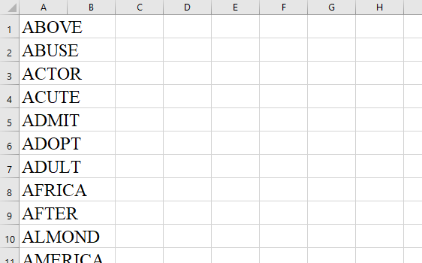

Figure 13

Codeword File

* In the Excel sheet codewords should be unique.
* They should be of single word.
* They should be of only characters but not numbers or special characters.
* Excel sheet should not be empty.
* Excel sheet should not have empty cells.

1. Instructor can edit the new added codewordset. He/She can edit, delete or add a new codewords to the set.
2. He/She can search for a codeword in that set or can view with pagination view. It defaults to 10 codewords per page and can change to 25,50 or 100.
3. Codewords can sort by ascending or descending order.
4. For adding a course, In Instructor Dashboard you will have chance to add courses by clicking on **+ ADD COURSE.**
5. Instructor can be able to fill in the details like Course Name, StartDate, EndDate, Uploading student details as per criteria given below, Selecting Codeword list and giving urls are instructors choice.

**Criteria for Creating Course:**

* 1. **Student List File:**

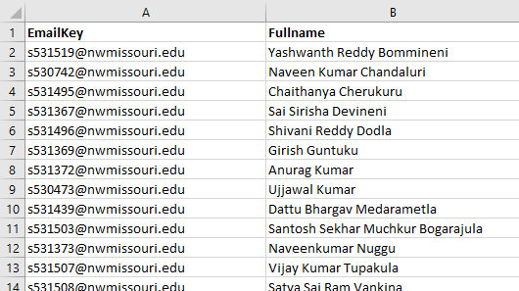

Figure 14

Student File Criteria

* It should have Email Key and Student Name in the File.

1. By clicking on **CREATE COURSE** button, it will come back to instructors dashboard page and course will be shown with Course Name, StartDate, EndDate, View and Delete buttons with Acknowledge status.
2. If instructor wants to delete course he/she can click on delete button and will confirm about deleting the course, if clicked on delete then course will be deleted from the view.
3. Instructor can view the course, where he/she can be able to edit course details, able to see the acknowledge status, percentage of students who acknowledged the codeword, search for a student, add, delete or edit student details, and can be able to sort according to email address and student name by clicking on Student Email and Student Name.
4. It defaults to 10 student per page and can change to 25,50 or 100.
5. For adding a new student click on **+ ADD NEW STUDENT** and give student email and student name.
6. In Instructor Dashboard, he/she can be able to see inactive courses by checking **Inactive Courses** button.
7. In NavBar, you will find logout button to logout.